

The Facts

AlpHa ® Na is a synthetic fulvic acid designed to maximize the potential of soil organic matter to complex soluble metals in the soil solution. The product AlpHa ® Na has been formulated to complex with toxic aluminium and other metals which can produce toxic effects in pasture and crops, including reducing yield and limiting the uptake and utilisation of plant nutrients.

When tested for effect against finely ground limestone (lime flour, LF) in pot trials, AlpHa ® Na applied at 2 l/ha produced growth rates higher than 100 times as much LF ( Bishop & Quin, 2012) -

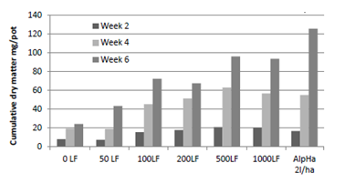

Figure Cumulative dry matter response of ryegrass (Moata) to lime flour applications of 0, 50, 100, 200, 500 and 1000 kg/ha and AlpHa ®Na at 2l/ha. When applied to an acid soil with an initial pH 4.8 (Bishop et al. 2012).

The ability of AlpHa ® Na to specifically reduce metal toxicity in ryegrass (Moata) was demonstrated in solution culture studies (Bishop, Jeyakumar & Quin, 2013). Shoot and root growth was measured accumulations a 6 week period. The test solutions used concentrations of Al from 0 to 1.6 mg/l, Manganese (Mn) from 0.05 to 40 mg/l, and Iron (Fe) from 1 to 80 mg/l. AlpHa ® Na concentrations used were 0, 0.2, 2 and 20 ul/l or l/ha.

At levels greater than 0.2 ul/l in the growth solution, AlpHa® prevented shoot growth suppression of Al up to a concentration of 1.6 mgAl/l, and reduced the effects on root growth suppression. The toxic effect of Mn and Fe on grass growth was delayed by the presence of AlpHa ® Na at 2ul/l for Mn and 0.2 ul/l for root growth in Fe.

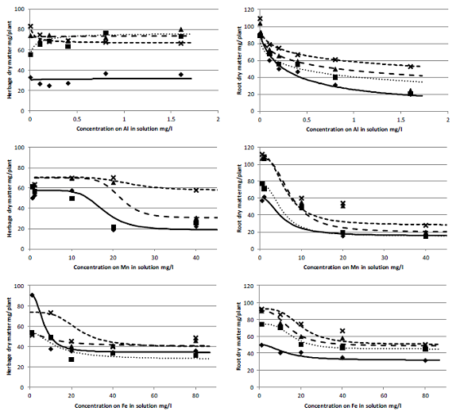

Figure Growth response curves for herbage and roots of ryegrass (Moata)grown in nutrient solutions containing added Al, Mn and Fe, with AlpHa ®Na added at 0( ), 0.2(■), 2.0 (▲) and 20 ul/l. Lines show the fitted herbicide dose response for each metal and AlpHa ® Na combination.

These published results provide the scientific evidence that AlpHa ® Na has the ability to reduce limestone application rates and reduce the toxic effects of Al on pasture production in acid soils.

**Additional benefits of Aapplying AlpHa ® Na with fertilisers**

When applied to phosphate fertiliser AlpHa ® Na can also inherence the effectiveness of the phosphate in a similar manner to limestone by reducing Al toxicity and increasing growth response (unpublished). The preliminary results of coating DAP with 2l/T with AlpHa ® Na showed an increase in herbage growth response by over 100% compared to the uncoated DAP, when applied to acid high P fixing soils. Similar results have been obtained in field trials.



Figure 3 Cumulative herbage growth of ryegrass (Moata) grown in acid Dannevirke silt loam (pH 4.3)in response to the addition of DAP (20 kgP/ha) coated with AlpHa ® Na, Calcium lignosulphonate (Cal-lig), wattle extract tannin (Clarotan ®) and slow release polyurethane (5RLPDAP)at rates equivalent to 2l/T and 5% in the case of 5RLPDAP. The Nil-P control using sulphate of ammonium as N source. Grass was cut at 26() and 49() days.



The results of these trials show that AlpHa ® Na is an effective product for controlling the effects of aluminium toxicity in pasture reducing the amount of limestone required and enhancing the effects of fertilisers limited by phytotoxicity.

**Bibliography**

Bishop, P., Quin, B., Pham, T. S., & Nguyen, L. (2012, February). The use of poly-carboxylic acids and sodium silicate to increase fertilizer P efficiency and reduce lime requirements on acid soils in New Zealand and Vietnam. In: *Advanced Nutrient Management: Gains from the Past - Goals for the Future*. (Eds L.D. Currie and C L. Christensen). http://flrc.massey.ac.nz/publications.html. Occasional Report No. 25. Fertilizer and Lime Research Centre, Massey University, Palmerston North, New Zealand.

Bishop, P., Jeyakumar, P., & Quin, B. (2013). Amelioration of Al, Mn and Fe toxicity in rygrass and clover, and wheat and rice, by poly-carboxylic acids. In: *Accurate and efficient use of nutrients on farms*. (Eds L.D. Currie and C L. Christensen). http://flrc.massey.ac.nz/publications.html. Occasional Report No. 26. Fertilizer and Lime Research Centre, Massey University, Palmerston North, New Zealand.