COMMERCIALISATION OF ONEsystem®
(WETTED, NBPT-TREATED PRILLED UREA)
IN NEW ZEALAND AND VICTORIA, AUSTRALIA

Bert F. Quin^{1,4}, Shane Harold ², Stewart Spilsbury³and Geoff Bates⁴
¹Global Sustainable Farming Ltd, New Zealand; ²Fert Wholesale Direct Ltd,
³FOO Technologies Pty Ltd, Australia; ⁴Pastoral Robotics Ltd, New Zealand
Email: bert.quin@gmail.com

Abstract
Granular urea is known to be an agronomically inefficient source of N when surface-applied, with Nitrogen Utilisation Efficiencies (NUEs) of 20-40%. Two of the main reasons for this include volatilisation losses of ammonia, and poor distribution efficiency to individual plants (coverage). However, its relatively low cost, high N content (46%) and ease of spreading makes it popular with farmers. Recently, granular urea treated with the urease inhibitor nbpt (SustaiN®, N-Protect® and Green Urea®) has taken an increasing share of the NZ and to a lesser extent in Australia. My minimising ammonia volatilisation, nitrogen utilisation efficiency (NUE) is improved 20-25% on average compared to granular urea.
Much greater efficiencies again have been achieved since 2005 by fluidising urea (either on-board the spreading truck or separately). Increases in efficiency of up to a factor of 2 (200%) have been recorded, provided nbpt is added. However, the high costs of specialised equipment, maintenance and narrow spreading widths have greatly limited the uptake of this technology.
In 2014 however, it was demonstrated that the same advantages in increased N efficiency could be achieved far more easily, practically and reliably, and with much improved spreading widths and much lower costs, using the new ONEsystem® technology.
ONEsystem® involves the wetting of prilled urea with a solution of nbpt during the spreading operation. The initial equipment used for trials was a quad-bike tow-behind spreader fitted with water ranks to carry the nbpt solution and spray nozzles. While this system is adequate for share-milkers who follow the cows with N, it became more problematic to supply the system at a size more appropriate for large farms and spreading contractors.
The existing fleet of NZ-built spreading trucks use chains or rubber belts to deliver product from the hopper to the spinning discs. While these systems work well for applying granular or semi-granular products at or above rates of 70 kg/ha, product delivery becomes highly variable at lower rates. This problem was eventually overcome by the development of new technology for delivering the product from the hopper to the spinning discs, allowing application rates as low as 20 kg product/ha with bout widths of 20m and cvs below 15%.
In Gippsland, Victoria, the concentration of sufficient clients within a small geographic area has allowed the commercial introduction (October 2016) of Kuhn tractor-mounted technology which incorporates variable rate application (VRA) and selectable modes for prills, granules and fine fertilisers. A 1000 litre water tank and nozzles for spraying the prills with nbpt have been fitted, along with a boom and smaller tank for gibberellic acid (GA) application.
The proven efficiency of ONEsystem® will face greater barriers to adoption in New Zealand, where a duopoly control over 90% of the market, and are reliant on continuing high sales of both NZ-made and imported granular urea (with and without nbpt treatment) for over 30% of their net profit.

Introduction
The use of granular urea in New Zealand has grown from 30,000 tonnes per annum (tpa) in the late 1980s to over 650,000 tpa (300,000 tonnes nitrogen pa) now; the majority is used on dairy and other intensive grazing farms.
While convenient to store, transport and spread, and relatively cheap to produce compared to most other N fertilisers, granular urea is very inefficient agronomically when surface-applied (as on pasture), with a Nitrogen Utilisation Efficiency (NUE) typically in the 20-40% range. This corresponds to EDM factors (Extra kg Dry Matter per kg N applied) of 5-15, with a default value of 10 frequently used by farm consultants and farmers.
These NUEs are only half those already being achieved with more efficient N fertilisers in horticulture and on some crops in any countries overseas.
Directly because of the poor efficiency, over half the 300,000 tonnes N being applied to pasture annually is lost to the environment. At a typical applied cost of about $1.50 per kg N (30 kg N/ha basis) , this wastage represents a loss of $225m annually – equal to the combined research budgets of AgResearch and DairyNZ – or over $650m in terms of the opportunity costs of the lost milk and beef production.
This wastage also of curse releases more than 150,000 tonnes N into the environmemt annually, as nitrous oxide greenhouse gas, volatilisation of ammonia (the precursor of PM_{2.5} particulate smog), and nitrate leaching.
Fertiliser N inefficiency is just as important as N losses from cow urine patches, yet receives very little research input in New Zealand. There is a real need to find alternatives that are more efficient agronomically while remaining cost-effective for the farmer.

Why is granular urea so inefficient on pasture?
There are 3 major reasons for this.
Firstly, the mismatch between granules applied and plant densities. At a typical 30 kg N/ha application rate, only 35 granules are applied per m². This compares to typical pasture plant densities of 400-500/m². It is simply not possible for all these plants to receive similar amounts of N, especially given the relatively short duration of the N in the soil before substantial environmental N losses occur. The soil zone with enriched N during granule dissolution rarely exceeds 20%. Some plants get a huge excess of N; many get none.
Second, granular urea is very susceptible to ammonia volatilisation during hydrolysis. This is compounded by the high concentrations of urea released into small volumes from granules; hydrolysis results in peak pH levels in the surrounding soil solution of 8-8.5. After decades of industry claims of volatilisation losses of only 0-5%, the scientific facts – an average 20% loss (range 5-40%) – have finally prevailed. This is similar to losses found in other temperate situations. Ammonia volatilisation does not require high air temperatures; losses can exceed 30% at 15ºC or less in windy conditions, or if insufficient rainfall occurs before or shortly after application to ensure the urea is washed below the soil surface.
Third, the nitrate-N eventually formed is susceptible to leaching, as it is with all types of N fertiliser. However, the relatively high concentrations of nitrate achieved around urea granules (because of the 46% N content), in a relatively small volume of the soil, means uptake by plants is slower. This increases the risk of nitrate leaching events occurring.

Alternative N fertilisers to urea
Urea (granular plus prilled) plus liquid ammonia comprise the majority of all fertiliser N sold globally. Several other types combine ammonium-N with other nutrients (eg with phosphorus (P) in mono-ammonium and di-ammonium phosphate (MAP and DAP), with sulphate-S in sulphate of ammonia (SOA), with nitrate-N in ammonium nitrate (AN), calcium ammonium nitrate (CAN), with urea and nitrate-N in urea ammonium nitrate (UAN). Others contain nitrate only (sodium and potassium nitrates).
Outside of damp, still conditions, or on very acid soils, NUEs with ammonium-N based fertilisers are typically 20% (range 10-30%) higher than granular urea, mainly because of reduced ammonia volatilisation. However, as they are typically 20-30% more expensive per kg N on an applied basis, their use in New Zealand has not generally increased proportionately. The exceptions are (i) DAP, where if the applied P cost is compared against single superphosphate (SSP), the N content represents very good value, particularly where sulphur (S) nutrient requirements are low; and (ii) by-product SOA, which, imported in containers, is now competitively priced per kg N against locally-manufactured and bulk-imported granular urea, particularly in low soil-S situations where the 24% sulphate-S content of SOA adds considerably to its value.

Attempts to improve the efficiency of urea on pasture in New Zealand and Australia
Significant attempts to improve the efficiency of urea are presented in Table 1, and discussed in more detail after.

Table 1. Attempts to improve the efficiency of fertiliser urea on pasture in New Zealand
-------------------------------------------------------------------------------------------------------------------
Method Mode of action NUE Cost On-farm practicality
change increase
_____________________________________________________________________________
Polymer delays N release; +0-30% +20-30% debatable; farmers
coating reduces volatilisation want response quickly

Spraying reduces volatilisation +5-30% +7-10% as good as urea
with nbpt and (indirectly)
(SustaiN®) nitrate leaching

Urea solution even coverage -10 to +10% +20% convenient through irrigation;
and uptake limited applcation rates;
highly prone to volatatilation

Fluidised urea better coverage 25-50% 30-50% specialised equipment
(FPA) required; poor bout width

Fluidised urea better coverage, 50-200% 35-60% specialised equipment
plus nbpt less volatilisation required; poor bout width
(Nhance) and nitrate leaching

ONEsystem® better coverage, 150-250% 10-20% as practical as gran. urea.
(wetted,nbpt- reduced volatilisation provided appropriate
treated prills) and nitrate leaching hopper delivery and
spinners are fitted
___________________________________________________________________________________

Options for coating granular urea
Polymer coating of granular urea (Bishop et al 2008, Edmeades et al. 2015) slows the release of the N by providing a temporary physical barrier to the dissolution and hydrolysis of the urea. This reduces ammonia volatilisation considerably, but unless the coating is done particularly well, it is difficult to predict how long the lag-period will be. Intensive pastoral systems are built around knowing as much as possible about feed availability and reliability week by week, so the quick response from normal urea, while inefficient, is a better practical fit. A mix of normal and polymer-coated urea might seem better, but this worsens again the ‘coverage’ of the rapidly-available N.
Traditional sulphur coating is similar to polymers, in that the primary focus was to provide an impervious shell around the urea, requiring at least 12%S by weight, to provide a delayed response. With both types of coating, it only takes a small hole for the urea to quickly escape. Extremely well coated products can have N release periods after application defined in weeks, eg 0-3,3-6 and so on. These are at least double the cost per kg N and hence used only in very high crop-value situations such as Japan.
More recently, coating with only 4% elemental S has been investigated. This S content is insufficient to act as a physical barrier to the release of the urea; instead, it is present to act as a local source of acidity as the very fine S is oxidised to sulphate-S by soil bacteria. This in turn offsets the build-up in soil pH in the soil solution around the granule as the urea is hydrolysed, minimising ammonia volatilisation. This product, containing 44% N and 4%S, also provides an agronomically-balanced 10:1 N:S ratio.
Coating – or more correctly spraying - granular urea with a solution of the urease inhibitor nbpt achieves a similar increase in effectiveness by a different route. The nbpt inhibits the hydrolysis of the urea by the urease enzyme for typically 5-7 days, again minimising volatilisation. (Watson et al. 2009). An indirect benefit is that, because the conversion to ammonium-N is slowed, so too is the conversion of this ammonium-N to nitrate-N. This reduces the quantity of nitrate at risk of leaching by avoiding the large peak in nitrate concentration that occurs with granular urea about 2-3 weeks after application (Watson et al. 2009).
Since its introduction in New Zealand and Australia by Summit-Quinphos in the early 2000s, sales of nbpt-treated urea has grown substantially. Combined sales of SustaiN (Ballance) and N-Protect (Ravensdown) are now challenging straight granular urea for market dominance, providing an average 20-25% increase in efficiency for a cost-premium of only 10%. Pivot sells a similar product (Green Urea) in Australia.
The effectiveness and reliability of coating organic materials such as humate and extracts from the Indian neem tree have not established; lack of product standardisation presents a further challenge.

True solutions of urea
Urea is highly soluble in water; stable saturated solutions contain approximately 20% N by weight. It obviously provides are far more even delivery of N to plants (called ‘coverage’ in the industry), but it is very limited in maximum application rates. Applications over 10 kg N/ha are likely to cause leaf scorch and temporarily reduced production due to rapid leaf uptake of urea and resulting internal urea and/or ammonia toxicity. It is also very susceptible to volatilisation of ammonia from both leaf surfaces and the soil. As a consequence, it is on average no more efficient than granular urea on pasture. Being in solution, very large, uneconomic rates of nbpt must be added to avoid volatilisation. For these reasons, its use is restricted to regular low-rate applications in irrigation systems, avoiding the normal spreading operation.
Fluidised urea products
The first massive improvements in urea efficiency on pasture were obtained by crushing granular urea and (separately or simultaneously) mixing it with between 10% and 40% of water to form a thick slurry or paste of fluidised urea. Such products were produced, by various types of on-the-go equipment, or pre-prepared for aerial application, and sold under names such as FPA (fine particle application), Nhance (fluidised nbpt-treated urea, Fig. 1), and Tow and Fert. Large increases in efficiency required the presence of nbpt to be reliable (Dewar et al. 2011). The poor bout widths and high capital and/or maintenance costs of the specialised equipment required limited the commercial uptake of these products. If crushing was too fine, leaf scorch checked pasture response for a few days.
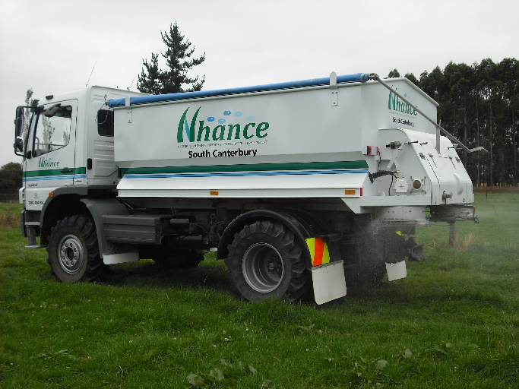
Fig 1. On-truck fluidisation of nbpt treated granular urea (Nhance).

And now ONEsystem®: the end-game in N efficiency?
Independently conducted and analysed field trials under grazing
ONEsystem® wetted, nbpt-treated prilled urea has been rigorously tested in independently-conducted, replicated and statistically analysed scientific trials under grazing conditions (Quin et al. 2015). A summary of the trial data for ONEsystem® and granular urea is shown in Fig. 2. These trials were laid down with a quad-bike tow-behind version of ONEsystem® (Fig. 3).
In Trial (a), Mid-Canterbury, ONEsystem® outperformed granular urea in each of the four application/grazing cycles, and overall (Fig. 2). Across the typical range of application of granular urea (25-50 kg N/ha per application), ONEsystem® produced 24 kg extra DM per kg N applied (the EDM factor) of 24, compared to only 10 for granular urea.
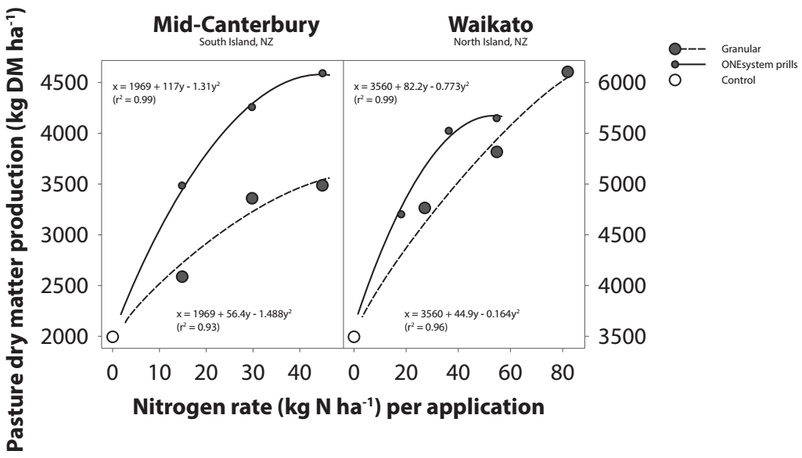
Fig. 2 Pasture production (kg DMha-1) form control (nil N; circle), 3 rates of granular urea (large dots) and 3 rates of ONEsystem® wetted, nbpt-treated prilled urea (small dots). From Quin et al. 2015, Four N applications were made at each site.

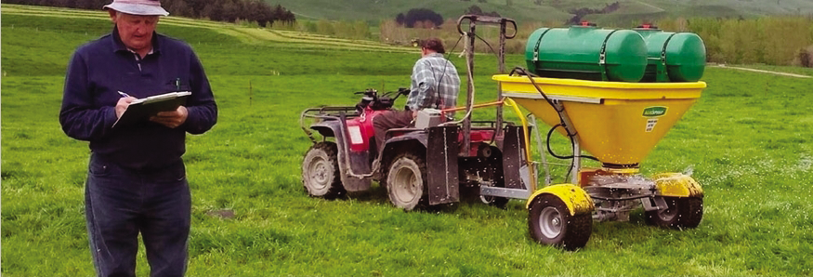
Fig.3. Scientist Dr Allan Gillingham and Field Technician Morris Gray conducting N fertiliser comparison field trials under grazing with the tow-behind modified for ONEsystem® application.

In Trial (b), in the Waikato, ONEsystem® initially outperformed granular urea by the same margin before becoming more similar in efficiency; this still resulted in an overall EDM factor of 17 for ONEsystem® compared to 10 (again) for granular urea (Fig. 2). It was assessed that rising temperatures in the high organic activity Waikato allophanic soil caused a progressively rapid decomposition of the nbpt in the soil, meaning nbpt application rates probably need to be doubled on this soil type.
ONEsystem® provides at least as good an increase in urea efficiency as fluidised, nbpt-treated urea, but with no grinding requirement, a much wider spread width, and no risk of leaf scorch. Total cost per kg N is only 10-20% higher than granular urea.
Reasons for superiority of one system
ONEsystem® achieves its efficiency by the following combination of factors:
- Better ‘coverage’; ie 350-400 prills per m² compared to 35 per m² at 30 kg N/ha. Plants get far more even access to fertilizer N;
- The nbpt minimises ammonia volatilisation, both from the soil and leaf surfaces;
- Wetting the prills allows many of them to adhere to the leaf, allowing some direct foliar uptake as the prills dissolve by adsorbing moisture, but slowly enough to avoid risk of leaf scorch. Urea adsorbed through the leaves and cuticles is more efficiently converted to protein by the plant than is nitrate taken up through the roots;
- The high ‘coverage’ of small prills on the soil surface prevents the formation of the very high pH levels (>8) that are reached around each granule of granular urea. This assists the nbpt in reducing ammonia volatiisation;
- The reduction in the rate of hydrolysis of urea to ammonium also means there is a slower, more gradual conversion to nitrate. This avoids the very high peak concentrations of leaching-susceptible nitrate that are typically reached 2-3 weeks after application around and beneath each granule of conventional granular urea;
- Very low cvs are easily achieved. Spread patterns have a more defined cut-off, further reducing losses to waterways.
The efficiency reached with ONEsystem® is unlikely to be exceeded more cost-effectively by any other type of N fertiliser.

Commercialisation of ONEsystem®
Quad or side-by-side tow behind for sharemilkers
The small tow-behind shown in Fig.3 used for the trials is based on the same equipment size used by many North Island share-milkers who follow the cows with an application of granular urea, with a 0.2 - 0.4m³ hopper tow-behind with added water tanks and spray nozzles. Converted to spreading wetted prills with a swath of 12-14 meters, and travelling at a typical speed 12 km/hr, this equipment will spread ONEsystem® over the typical 3 ha grazed per day in about 20 minutes, easily achieved while the cows are walking to the milking shed.
This size equipment is also easily mounted on the 8m-width tractor mounted Spikey® urine patch detection and treatment (Bates et al 2017).
Large farm or contractor ONEsystem® equipment
For larger dairy farms, intensive beef farms and for contractors, a larger, more robust vehicle with significantly wider spread (>20m bout width) is required. Different paths have been taken in NZ and Australia.
The first commercial ONEsystem® built in New Zealand is built on an existing Mercedes Benz spreading truck refitted with a smaller hopper, a 2000 l water tank, a proprietary system for delivering very low rates of fertiliser very evenly to the spinning discs, which have themselves been custom-built to maximise prill bout width (22m) and optimise spreading evenness. (Fig. 4). This unit is now operating in Southland.
In Victoria, the close proximity of sufficient client farms in east Gippsland made the use of a tractor practicable. A Kuhn unit providing settings for granular, prilled and fine fertilisers and a VRA system was purchased by the contractor, mounted on a John Deere 6130R tractor, and fitted with a water tank, nozzles for prill-wetting and a spray boom for GA application (Fig. 5). It has been working commercially since October 2016, and is capable of covering 100 ha/day including driving between farms.
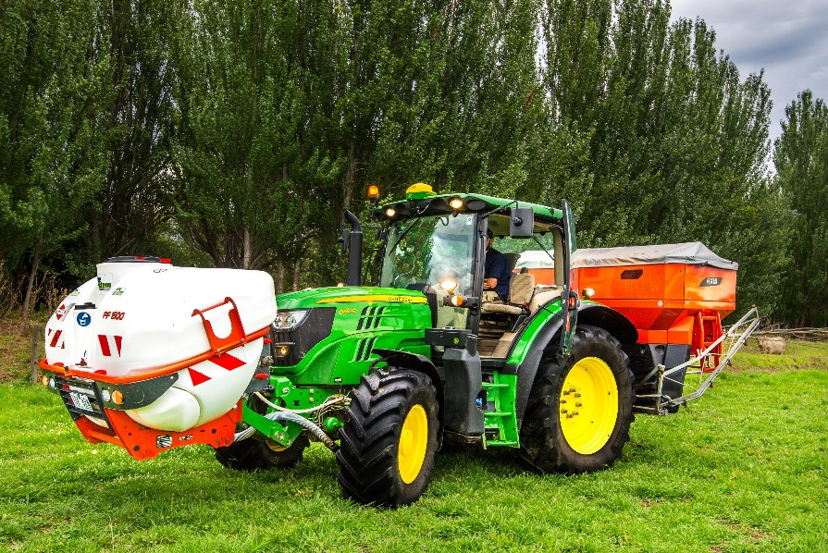
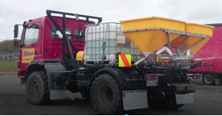
John Deere 6130 R (features):
- Starfire 3000 receiver
- Greenstar 3 2630 Display
- Heated seats
- Suspension on front axle
- Premium Cab
- Trailer fittings
Fig. 4. Truck-mounted ONEsystem®.

Fig. 5. Tractor-mounted ONEsystem®.

Conclusions: Barriers to adoption
After 15 years of experimentation, a simple, practical system for gaining far greater nitrogen utilisation efficiency from surface-fertiliser urea has been developed and brought to market. ONEsystem® utilises wetted, nbpt-treated prilled urea to achieve double the efficiency of granular urea (and 1.7 times that of nbpt-treated granular urea).
It does this by reducing ammonia volatilisation and providing more even N supply to individual pasture plants and as a consequence less nitrate leaching.
These benefits are likely to result in relatively rapid uptake of the technology in Australia, where there is more competition in fertiliser supply and spreading, and therefore more commercial interest in new fertiliser technologies.
In New Zealand however, the presence of an all-powerful duopoly in fertiliser supply, and the consequent dependency of the fertiliser spreading industry, creates far greater challenges to adoption of the ONEsystem® technology. The potential for total urea usage to be halved is seen as a huge commercial risk by the duopoly management, despite the fact that the owners are the very farmers who stand to gain the most in reduced fertiliser N costs. And all New Zealanders would gain from the reduced N losses to the atmosphere and as nitrate leaching.

References
Bishop, P.A., Liu, H.Y., Hedley, M.J. and P. Loganathan 2008. New Zealand made controlled release coated urea increases winter growth rates of Italian ryegrass with lower N leaching than uncoated urea. Proc. NZ Grassland Assoc. 70: 85-89.
Dewar, D., Zaman, M., Rowarth, J.S., Blennerhassett, J. and M.H. Turnbull 2011. Urease inhibitor reduces N losses and improves plant-bioavailability of urea applied in fine-particle and granular forms under field conditions. Agric., Ecosystems and Env. 144: 41-50.
Edmeades, D.C. 2015. The evaluation of a controlled release nitrogen fertiliser. J. NZ Grasslands 77: 147-152.
Quin, B.F., Gillingham, A.G., Baird, D., Spilsbury, S. and M. Gray 2015. A comparison under grazing of pasture production, pasture N content and soil mineral N levels between granular urea and ONEsystem® on two contrasting dairy farms in New Zealand. J. NZ Grasslands 77: 259-268.
Spilsbury, S. and B.F. Quin 2017. Gibberellic acid application in summer (applied with wetted, nbpt-treated prilled urea) increases pasture production on five irrigated dairy farms in Victoria, Australia. In: Science and policy: nutrient management challenges for the next generation. (eds L.D. Currie and M.J. Hedley). http://flrc.massey.ac.nz/publications.htmal. Occasional Report No. 30. Fertilizer and Lime Research Centre, Massey University, Palmerston North, New Zealand. 7 pages.
Watson, C.J., Laughlin, R.J. and K.L. McGeough 2009. Modifications of nitrogen fertilisers using inhibitors: opportunities and potentials for improving nitrogen use efficiency. Proc. Of the Int. Fert. Soc., London: ISBN 978-0-85310-295-3.

